# **How to (easily) submit a sample email to HCU information security**

1. Choose your preferred email client:

### Microsoft Outlook

In the opened email click on **File** and then **Save as:**

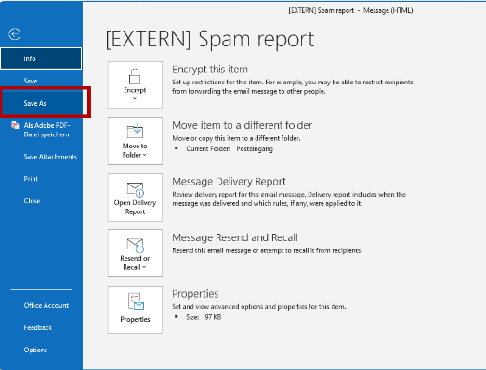

### SoGo

In the opened email click on **more** options (three vertical dots) on the upper right corner and then **Download message (zip):**

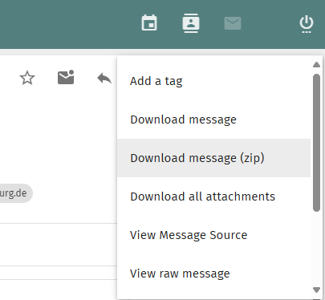

1. Save the message to some place on your computer. After finishing these steps, the local file can be deleted.
2. Log into HCU Cloud at <https://cloud.hcu-hamburg.de> and upload the email file by clicking **New** and **Upload files**.

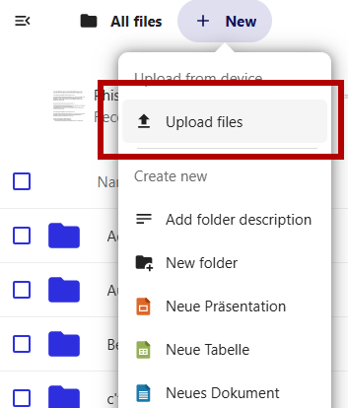

1. Share the uploaded file with HCU information security.

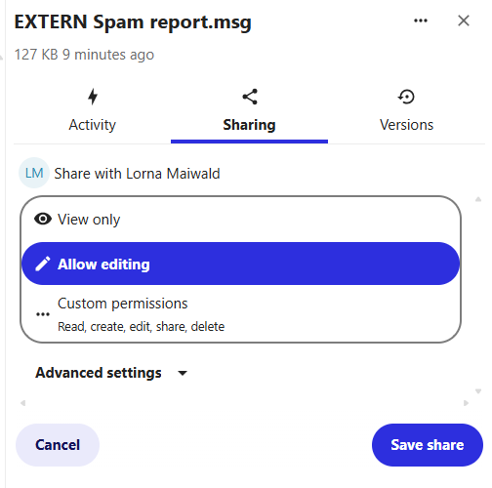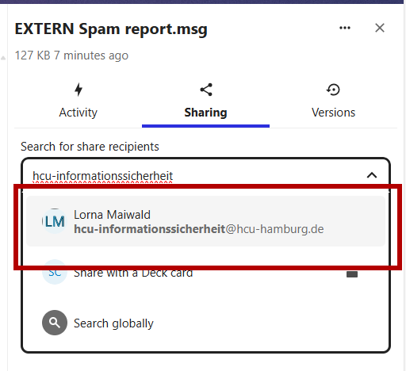

1. Please give me some time to respond. Afterwards the uploaded file can be deleted.